Tribhuvan University
Faculty of Humanities and Social Sciences
Jana Bhawana Campus
Godawari, Lalitpur


A Practical Work on
Advanced JAVA Programming
For The Partial Fulfillment of The Requirements for The
Bachelor of Computer Application Program

Internal Examiner: External Examiner:
Er. Suman Mali ...……………...
BCA Department

Submitted By:
Sudip Lo
6-2-253-26-2022
BCA 6th Semester
JANA BHAWANA CAMPUS
GODAWARI-11, LALITPUR
Advance Java Programing
Practical File Record

Name: Sudip Lo Reg No: 6-2-253-26-2022
S.N. | Name of Practical | Date | Signature
1. | WAP that works as a simple calculator. Use a grid layout to arrange buttons for the digits and for the +, -, % operation. Add a text field to display the result. Handle any possible exceptions like divided by zero.
2. | WAP to demonstrate the use of JSwing Components and layout managers to it.
3. | Create a login page in Swing and add events to it on click of login button
4. | Write a JDBC program, to create an employee table insert update and delete data and display the details of employee whose department is IT using prepared statement.
5. | WAP to demonstrate the Remote method invocation in java.
6. | WAP which displays cookie id.
7. | Write a servlet program to select the details of employee and display on browser in appropriative format.
8. | Write a JSP program for basic arithmetic functions.
9. | Write a JSP program to create a register form. Count the no. of visitors and display the name of logged in user using session.

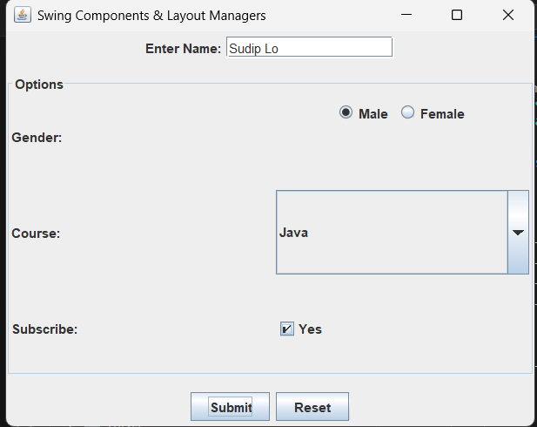
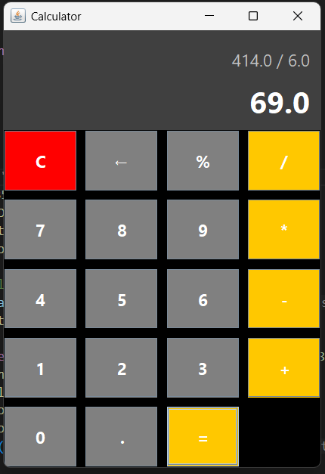
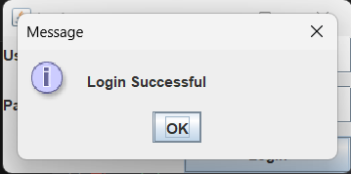
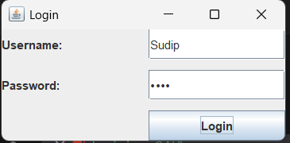
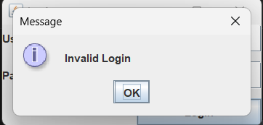
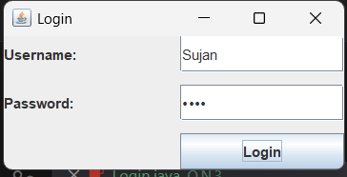

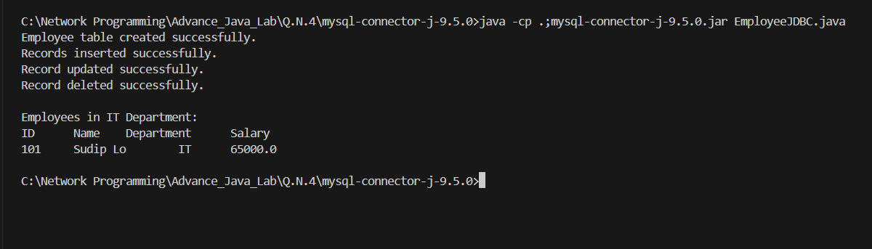

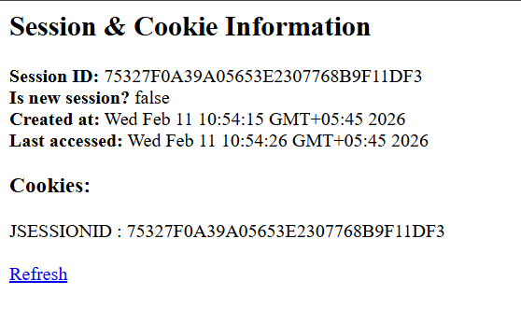
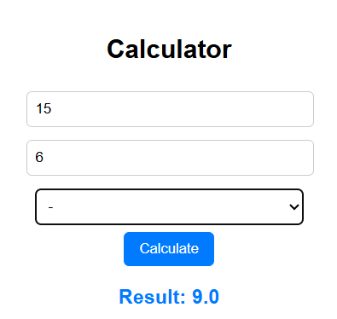
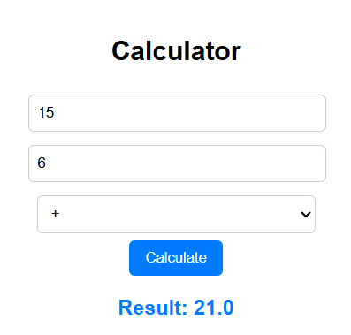
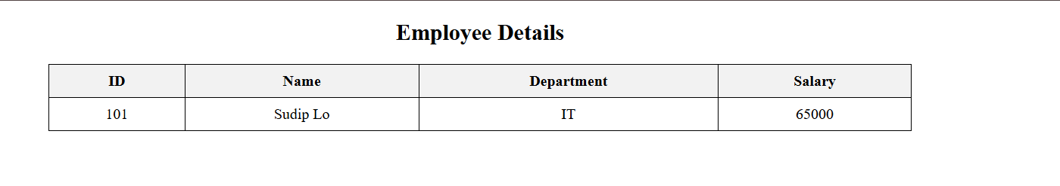

Tribhuvan University
Faculty of Humanities and Social Sciences
Jana Bhawana Campus
Godawari, Lalitpur

A Practical Work on
Network Programming
For The Partial Fulfillment of The Requirements for The
Bachelor of Computer Application Program

Internal Examiner: External Examiner:
Er. Suman Mali ...……………...
BCA Department

Submitted By:
Sudip Lo
6-2-253-26-2022
BCA 6th Semester
